Git bashes uses the linux commands only, you can switch and list the files & directories as shown below.

# Here my Git working directory is: D:\GitWorkingDirectory\Git_project_Directory

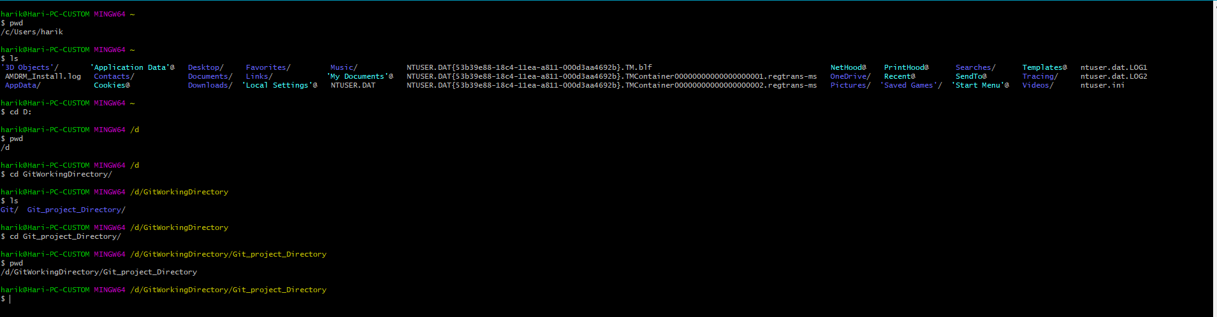

Another way to switch to the directory using the below way, switch to the directory and right click and select “Git bash Here”

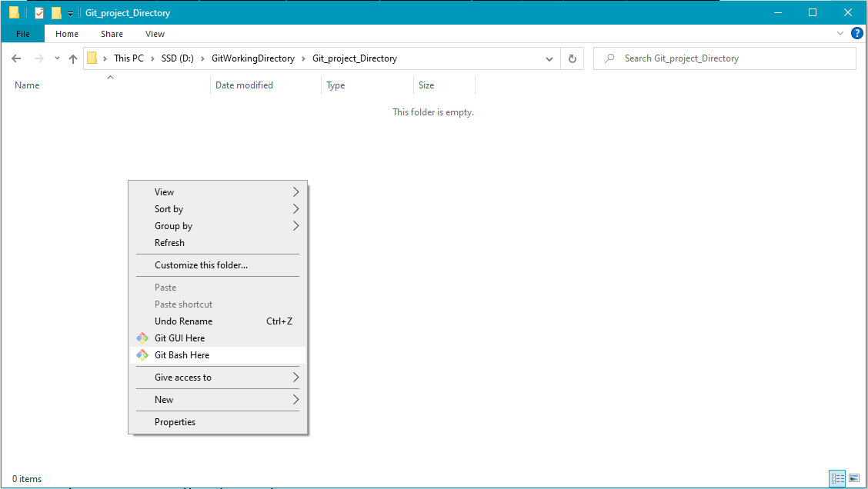

To initialize the git repository on you working directory, go to that directory and use the below command.

# git init

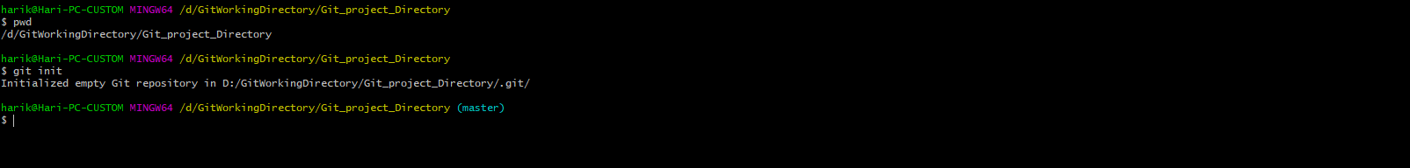

Once you initialize the git repository it will create a hidden folder with the name .git.



